# IC-06A Acceleration due to Gravity (Pendulum + Ball-Drop)

Rev 10-16-2023

## 6.1 OBJECTIVE

The purpose of this experiment is to determine the acceleration due to gravity by using a simple pendulum, and by dropping a ball.

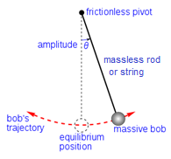

## 6.2 MATERIALS

1. String 2. Small Mass

3. Stopwatch 4. Meter stick

5. Support for Pendulum 6. Ball

## 6.3 PENDULUM

#### 6.3.1 INTRODUCTION

A point mass attached to a light string forms a simple pendulum. When the mass is pulled to one side and let go, it swings back and forth. The time taken for one complete vibration, i.e. from one extreme to the other, and back to the first, is called the Time Period, T. The time period depends on the acceleration due to gravity, g, and the length of the pendulum. By measuring the length of the pendulum and the time period, the value of g can be found from the equation:

$T=2π \sqrt{L/g}$ (1)

Squaring both sides:

$T^{2}=4π^{2}L/g$

Or $L= \frac{g}{4π^{2}}T^{2}$ (2)

Compare this to the equation of a straight line: $y=mx+b$. In this comparison, the y-intercept ‘*b*’ is zero, and the slope *m* is $\frac{g}{4π^{2}}$. On a plot of *L* on the y-axis and *T2* on the x-axis the slope is $\frac{g}{4π^{2}}$ from where the value of *g* can be found.

#### 6.3.2 PROCEDURE

1. Obtain a mass of around 20 to 50 grams. The physical size of the mass should be small. This will become the bob of the pendulum.
2. Tie the mass to a string that is about two meters long. Tie the other end of the string to a sturdy support to hang the pendulum. Keep the length of the pendulum about 1.50 meters. You should have enough space so that the pendulum can swing with a small amplitude.
3. Measure and note the length of the pendulum, which is from where the string oscillates, to the middle of the bob.
4. Pull the bob to one side, so that the string makes an angle of about 5° with the vertical (the angle does not have to be exact). Let the mass go. As the mass swings, make sure it is swinging back and forth, and not in an elliptical path.
5. Start the stopwatch (available in your cell-phone) when the mass is at one extreme position. Note the time taken for the pendulum to make 25 complete vibrations.
6. Reduce the length of the pendulum by about 10 cm and repeat procedure 3, 4 and 5.
7. Continue till the pendulum is about 50 cm long.
8. Plot a graph between length on the y-axis and *T2* on the x-axis. Find the Least Square Fit straight line for the data. Use the slope of the line to obtain the value of $g$.
9. Compare with the accepted value and find the percent error.

#### Note:

* The exact length of the pendulum is not important. Use lengths based on the space that is available to you.
* The number of vibrations can be changed. When the pendulum is long, it may take too long to count 25 vibrations. Use your judgement to get a good result for the value of ‘ $g$’.
* You can use the Capstone Software to draw the graphs and find the slopes.

## 6.4 BALL DROP

#### 6.4.1 INTRODUCTION

When a ball (or any other object) is dropped from a height $y_{i}$ with an initial speed of zero, it falls down with an acceleration = − m/s2. Assuming that the resistance due to air is negligible, by measuring the time that the ball takes to hit the floor, one can calculate the value of $g$, by using the equation:

$y_{f}= y_{i}+ v_{y_{i}}\left(t_{f}- t_{i}\right)+\frac{1}{2} a_{y} {\left(t_{f}- t_{i}\right)}^{2}$ (1)

Where $y_{i}$ = initial position (at time $t_{i}$).

$y_{f}$ = final position (at time $t_{f}$) = 0.00 m.

${v_{y}}_{i}$ = Initial velocity in the y-direction (at time $t_{i}$) = 0.00 m/s.

$a_{y}$ = Acceleration in the y-direction (which is constant, not function of time) = − m/s2.

In our case, the equation reduces to:

$0= y_{i}+ \frac{1}{2} (-g) {\left(t_{f}- t_{i}\right)}^{2}$ (2)

Or

$y_{i}= \frac{1}{2} g {\left(t_{f}- t_{i}\right)}^{2}$ (3)

#### 6.4.2 PROCEDURE

1. 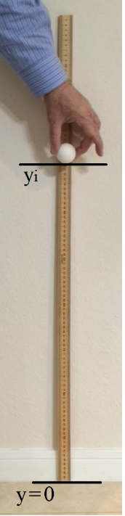Hold a meter stick vertically, with its zero touching the ground.
2. Hold a ball with its lowest point at 30 cm position. Let the ball go.
3. Measure the time ‘*t*’ that the ball takes to hit the ground. You can do this by using your cell-phone.
4. Repeat steps 2 and 3 with the ball being dropped from several different heights, each being about 20 cm apart.
5. Plot a graph between the square of the time, *t2*, on the x-axis, and the height *yi* on the y-axis. Fit a straight line to the data.
6. Determine the value of $g$ from the slope of the line. (note: slope ≠ $g$).

Note:

* You can increase the accuracy of the time measurement if you have two cellphones. Think how?
* You can increase the accuracy of the time measurement if you drop the ball from greater heights – use two meter sticks, one on top of the other.

## 6.5 PRECAUTIONS

#### Pendulum

1. The bob should be heavy enough to keep the string taut.
2. The bob should be of small physical size, preferably close to a spherical shape.
3. The string should not be stiff.
4. The point of support of the string should not move with the oscillations.
5. The amplitude should be small (e.g. if the string is one meter long, the amplitude should not be more than about 10 cm). This is because equation (1) is valid for small angle oscillations.
6. The pendulum should swing back and forth, not in an elliptic path.
7. The length of the pendulum is from the point of support to the center of the bob.

#### Ball Drop

1. Measure the height of the ball from the ground to the lowest point in the ball (not to its center).
2. The ball should not be of low density, e.g. do not use a ping pong ball. The air resistance will slow it down.

## 6.6 IC-06A Acceleration due to Gravity using Pendulum and Ball Drop Report Form

#### PENDULUM

|  |  |  |  |  |
| --- | --- | --- | --- | --- |
| **Length of pendulum, L** | **Number of vibrations, N** | **Time for N vibrations, t** | **Time Period, T = t / N** | **Time Period squared, T2** |
|  |  |  |  |  |
|  |  |  |  |  |
|  |  |  |  |  |
|  |  |  |  |  |
|  |  |  |  |  |
|  |  |  |  |  |

Value of slope from the graph: ___________

Value of ‘ $g$’ found from the slope: _________ Percent error in ‘ $g$’: _________ (attach graph)

#### BALL-DROP

|  |  |  |  |  |
| --- | --- | --- | --- | --- |
| **Drop number** | **Height from where the ball is dropped**  **yi** | **Time of fall of ball**  **t** | **t2** | **Calculated value of ‘g’** |
|  |  |  |  |  |
|  |  |  |  |  |
|  |  |  |  |  |
|  |  |  |  |  |
|  |  |  |  |  |
|  |  |  |  |  |
| **Average value of g** | | | |  |

Value of slope from the graph: ___________ Value of ‘ $g$’ found from the slope: ________

Percent error in ‘ $g$’: _________ (attach graph)

Percent difference in the two values of ‘g’: ____________

## 6.7 REPORT SUBMISSION

Upload the following in the Report for this Lab:

|  |  |  |
| --- | --- | --- |
|  |  | Points in report |
| 1 | The completely filled up “Report Form” for Pendulum. Make sure to include units of measurements. | 10 |
| 2 | Graph of Length versus T2 for pendulum showing the slope of the best fit line. Don’t forget to label the axes. | 10 |
| 3 | The completely filled up “Report Form” for Falling Ball. Make sure to include units of measurements. | 10 |
| 4 | Graph of *yi* versus T2 for falling ball showing the slope of the best fit line. Don’t forget to label the axes. | 10 |
| 5 | Sources of Error in this experiment. Indicate the major sources of error. Make a List. | 5 |
| 6 | Discussion of Results | 10 |
|  | Total | 55 |

“Sources of Error” and “Discussion of Results” are two separate headings

**Extra Credit:** Uploading a video showing your experiment being performed.

## 6.8 POINTS TO THINK ABOUT

1. Why should the amplitude be small (compared to the length of the pendulum)?
2. Why would a pencil not be a good choice for the bob of the pendulum?
3. Why should the dropped ball not be of low-density material?
4. How can you use a cell phone (or two cell phones) to great advantage in this lab?

## 6.9 SAMPLE DATA

#### PENDULUM

|  |  |  |  |  |
| --- | --- | --- | --- | --- |
| **Length of pendulum, L**  **(m)** | **Number of vibrations, N** | **Time for N vibrations, t**  **(s)** | **Time Period, T = t / N**  **(s)** | **Time Period squared, T2**  **(s2)** |
| **1.0** | **25** | **48.3** | **1.93** | **3.73** |
| **1.5** | **25** | **63.2** | **2.53** | **6.39** |
| **2.0** | **20** | **55.2** | **2.76** | **7.62** |
| **2.5** | **20** | **62.8** | **3.14** | **9.86** |
| **3.0** | **10** | **36.4** | **3.64** | **13.25** |
| **3.5** | **10** | **38.1** | **3.81** | **14.52** |

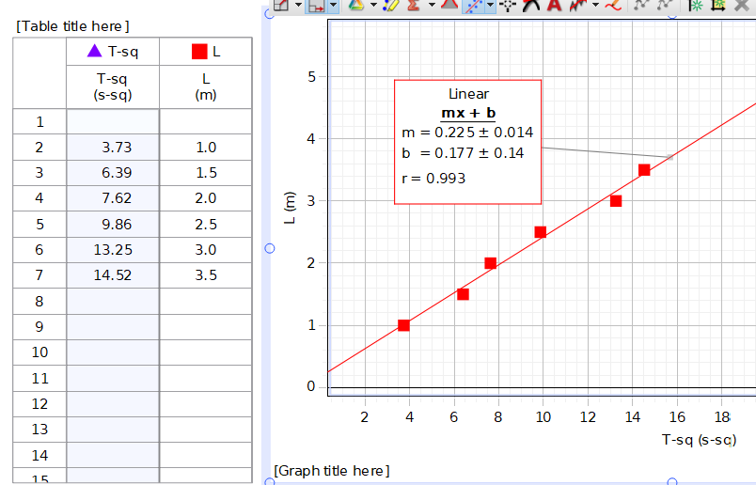

Slope = 0.225

Slope = $g/4π^{2}$

$g$ = slope *4 * π2 = 0.225 * 4 * π2 = 8.88 m/s2

percent error = 100 * (8.88 – 9.8) / 9.8 = 9.39 = 9%

#### BALL-DROP

|  |  |  |  |
| --- | --- | --- | --- |
| **Drop number** | **Height from where the ball is dropped**  **yi** | **Time of fall of ball**  **t** | **t2** |
| **1** | **3.00 m** | **0.80 s** | **0.64 s2** |
| **2** | **4.00 m** | **0.91 s** | **0.828 s2** |
| **3** | **5.00 m** | **0.98 s** | **0.96 s2** |
| **4** | **6.00 m** | **1.11 s** | **1.23 s2** |
| **5** | **7.00 m** | **1.21 s** | **1.464 s2** |

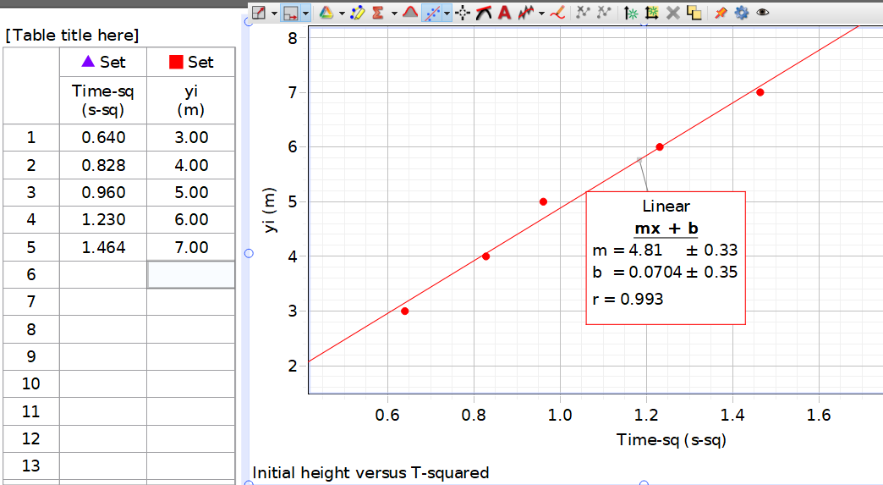

Slope = 4.81

= 2*slope = 9.62 m/s2

percent error = 100 * (9.62 – 9.8) / 9.8 = 1.84 = 2%